

Q5:

(a)

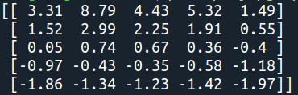

Same as Figure 3.2

(b)

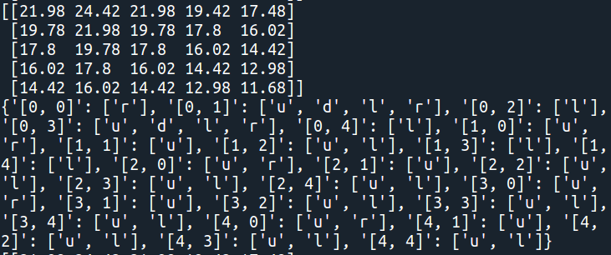

Same as Figure 3.5. The dictionary contains derived optimal policy, which key is state and value is action.

(c)

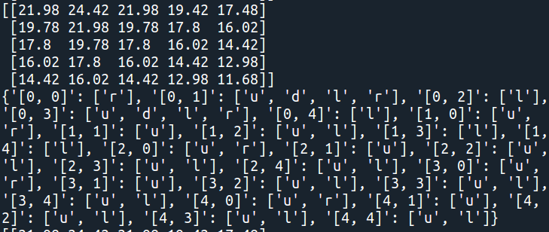

Q6:

1. Yellow indicates positive, blue indicates negative. The color in the middle of these four graphs indicates ‘0’.

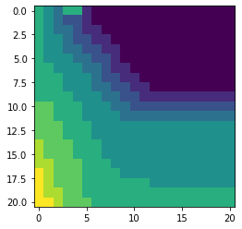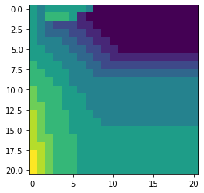

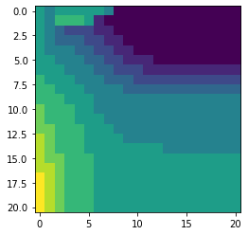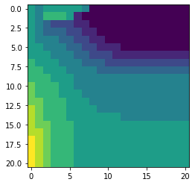

$π_{1}$*to $π_{4}$ (top-left to bottom-right), with initial $π_{0}$ has 0 as action for every state*

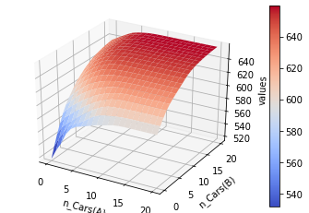

*3D-plot of $v_{π_{4}}$, maximum state value located at (20,20)*

1. The reward will change when making those modifications. When an employee is able to help switching cars the cost on switching in one of the directions will decrease by one, so I assume that employee lives at the second place and thus changed the reward when moves cars from the first place to the second from **reward =** **n_rented*10 – 2*num_movedCars** to **reward = n_rented*10 – 2*max((num_movedCars-1),0)**, and reward function for the other direction remains unchanged. In this case the optimal policy should be tend to switch more cars in one direction.

For the second case, when the parking lot charge for extra fees there will be an extra cost which result in lower reward, so I subtracted an extra term parking_fee if the total number of cars in that place is more than 10, as **n_rented*10 – 2*num_movedCars – parking_fee**. And I think the optimal policy should tend to keep less cars in both locations.

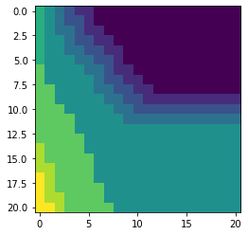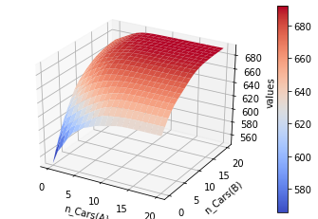

$π_{4}$*and 3D-plot of $v_{π_{4}}$ of employee problem*

As a result, the policy tends to move more cars in one direction and the other direction remains the same. The state values are also rise in general, since the cost of moving cars decreased, while the peak value still appears in (20,20).

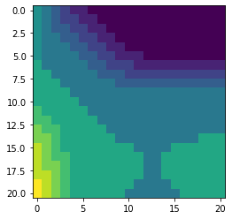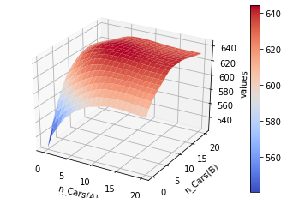

$π_{4}$*and 3D-plot of $v_{π_{4}}$ of parking fee problem*

As a result, the policy tends to keep less cars in both locations, and sometimes it doesn’t even move the cars when one of the locations has more than 15 cars because it wants to prevent being charged for extra parking fee for the other parking lot. The state values are also decreased in general, since the reward has been subtracted by extra parking fee, and it also impact the peak value which appears to be (10,10). It makes sense because keeping 10 cars in both parking lot is the best state that maximizing number of cars and avoiding extra parking fee.

